Baseline model

NBN

5/9/2020

## R Markdown

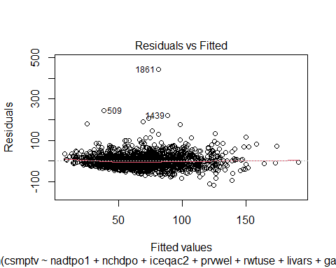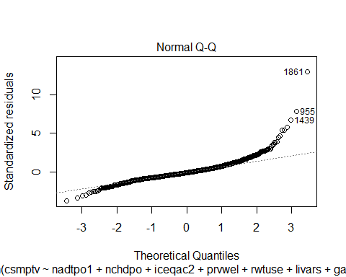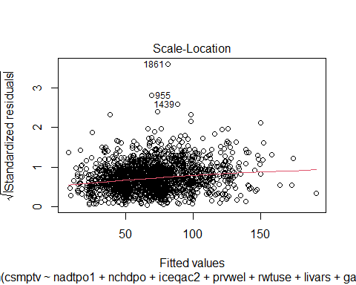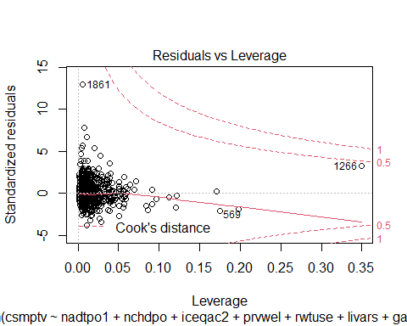

##   
## Call:  
## lm(formula = csmptv ~ nadtpo1 + nchdpo + iceqac2 + prvwel + rwtuse +   
## livars + garden + pmnpol + bath, data = fitdata, weights = weight,   
## na.action = "na.exclude")  
##   
## Weighted Residuals:  
## Min 1Q Median 3Q Max   
## -128.08 -19.30 -4.17 13.99 442.24   
##   
## Coefficients:  
## Estimate Std. Error t value Pr(>|t|)   
## (Intercept) 37.3103 2.8417 13.129 < 2e-16 ***  
## nadtpo1 24.2106 1.0445 23.180 < 2e-16 ***  
## nchdpo 11.3146 1.0714 10.561 < 2e-16 ***  
## iceqac2precarious -4.2512 2.8360 -1.499 0.13406   
## iceqac2modest 2.1736 2.1156 1.027 0.30437   
## iceqac2higher 7.7481 2.7534 2.814 0.00495 **   
## prvweloutdoor -6.1919 6.1806 -1.002 0.31657   
## prvwelindoor 14.0663 15.9847 0.880 0.37899   
## prvwelboth -17.3960 5.8455 -2.976 0.00296 **   
## rwtuseoutdoor -2.9399 2.2872 -1.285 0.19883   
## rwtuseindoor -15.4644 9.1537 -1.689 0.09132 .   
## rwtuseboth -27.3678 2.3473 -11.659 < 2e-16 ***  
## livars 3.1703 0.9747 3.252 0.00117 **   
## gardenyes 7.3202 2.2396 3.269 0.00110 **   
## pmnpolyes 22.6959 6.9966 3.244 0.00120 **   
## bathyes 6.8840 1.9799 3.477 0.00052 ***  
## ---  
## Signif. codes: 0 '***' 0.001 '**' 0.01 '*' 0.05 '.' 0.1 ' ' 1  
##   
## Residual standard error: 34.21 on 1700 degrees of freedom  
## (403 observations deleted due to missingness)  
## Multiple R-squared: 0.3856, Adjusted R-squared: 0.3802   
## F-statistic: 71.14 on 15 and 1700 DF, p-value: < 2.2e-16

## Analysis of Variance Table  
##   
## Response: csmptv  
## Df Sum Sq Mean Sq F value Pr(>F)   
## nadtpo1 1 854976 854976 730.4730 < 2.2e-16 ***  
## nchdpo 1 154531 154531 132.0282 < 2.2e-16 ***  
## iceqac2 3 25828 8609 7.3556 6.741e-05 ***  
## prvwel 3 4451 1484 1.2676 0.2839272   
## rwtuse 3 141806 47269 40.3855 < 2.2e-16 ***  
## livars 1 27877 27877 23.8174 1.158e-06 ***  
## garden 1 13931 13931 11.9026 0.0005743 ***  
## pmnpol 1 11434 11434 9.7692 0.0018046 **   
## bath 1 14149 14149 12.0888 0.0005200 ***  
## Residuals 1700 1989750 1170   
## ---  
## Signif. codes: 0 '***' 0.001 '**' 0.01 '*' 0.05 '.' 0.1 ' ' 1

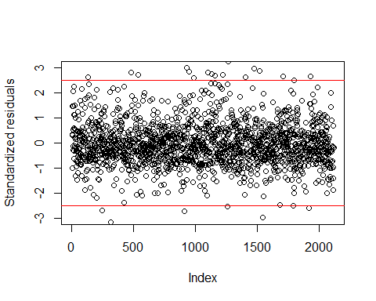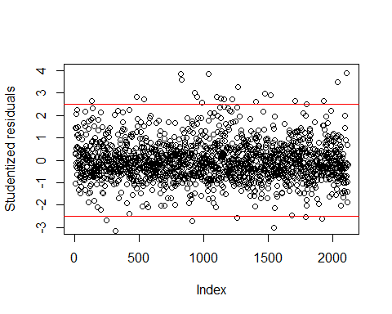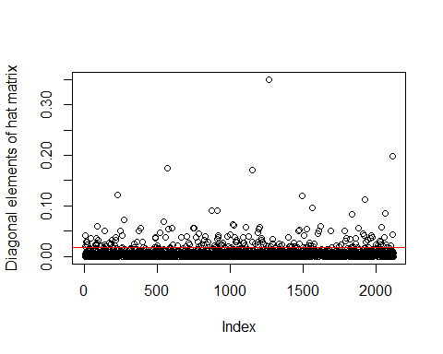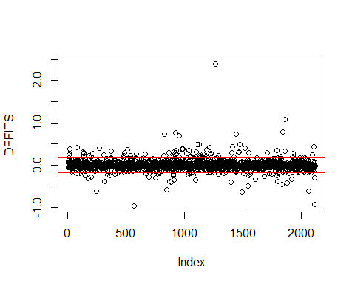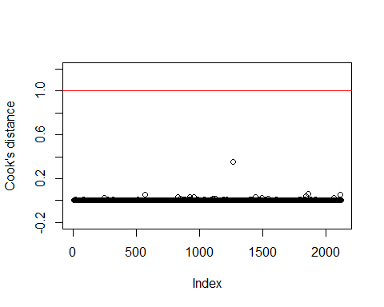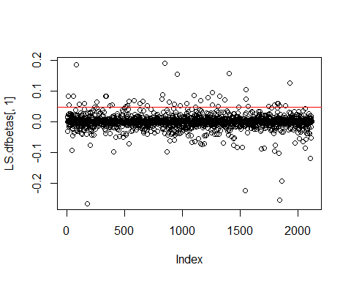

##   
## Call:  
## ltsReg.formula(formula = csmptv ~ nttppos + iceqas + livars,   
## data = fitdata, weights = weight, na.action = "na.exclude",   
## alpha = 0.75)  
##   
## Residuals (from reweighted LS):  
## Min 1Q Median 3Q Max   
## -71.361 -18.114 -0.353 17.288 71.483   
##   
## Coefficients:  
## Estimate Std. Error t value Pr(>|t|)   
## Intercept 65.5892 0.7006 93.623 < 2e-16 ***  
## nttppos 22.0469 0.7531 29.274 < 2e-16 ***  
## iceqas 1.7568 0.7425 2.366 0.0181 *   
## livars 3.4834 0.7813 4.458 8.83e-06 ***  
## ---  
## Signif. codes: 0 '***' 0.001 '**' 0.01 '*' 0.05 '.' 0.1 ' ' 1  
##   
## Residual standard error: 28.28 on 1631 degrees of freedom  
## Multiple R-Squared: 0.3807, Adjusted R-squared: 0.3796   
## F-statistic: 334.2 on 3 and 1631 DF, p-value: < 2.2e-16

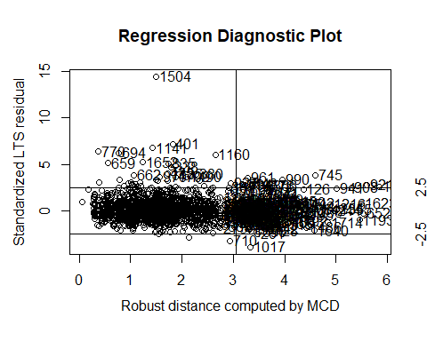

##   
## Call:  
## lmrob(formula = csmptv ~ nadtpo1 + nchdpo + iceqac2 + prvwel + rwtuse + livars +   
## garden + pmnpol + bath, data = fitdata, weights = weight, na.action = "na.exclude")  
## \--> method = "MM"  
## Residuals:  
## Min 1Q Median 3Q Max   
## -109.452 -17.516 -1.102 18.687 449.476   
##   
## Coefficients:  
## Estimate Std. Error t value Pr(>|t|)   
## (Intercept) 38.2330 2.4458 15.632 < 2e-16 ***  
## nadtpo1 23.2973 1.0926 21.322 < 2e-16 ***  
## nchdpo 10.8343 1.3554 7.994 2.4e-15 ***  
## iceqac2precarious -4.4642 2.8749 -1.553 0.120654   
## iceqac2modest -0.9318 1.8706 -0.498 0.618451   
## iceqac2higher 3.7601 2.4503 1.535 0.125079   
## prvweloutdoor -10.9802 9.5109 -1.154 0.248459   
## prvwelindoor -21.8284 22.2197 -0.982 0.326048   
## prvwelboth -19.3425 7.7226 -2.505 0.012350 *   
## rwtuseoutdoor -3.7637 2.1303 -1.767 0.077456 .   
## rwtuseindoor -11.8646 7.9400 -1.494 0.135287   
## rwtuseboth -26.5816 2.0511 -12.960 < 2e-16 ***  
## livars 3.6659 0.9449 3.880 0.000109 ***  
## gardenyes 7.8579 2.2535 3.487 0.000501 ***  
## pmnpolyes 24.9676 8.1140 3.077 0.002124 **   
## bathyes 4.4785 1.7547 2.552 0.010790 *   
## ---  
## Signif. codes: 0 '***' 0.001 '**' 0.01 '*' 0.05 '.' 0.1 ' ' 1  
##   
## Robust residual standard error: 24.18   
## (403 observations deleted due to missingness)  
## Multiple R-squared: 0.4766, Adjusted R-squared: 0.4719   
## Convergence in 17 IRWLS iterations  
##   
## Robustness weights:   
## 15 observations c(401,659,662,694,710,745,770,835,1022,1141,1160,1490,1504,1652,1709)  
## are outliers with |weight| = 0 ( < 5.8e-05);   
## 137 weights are ~= 1. The remaining 1564 ones are summarized as  
## Min. 1st Qu. Median Mean 3rd Qu. Max.   
## 0.001164 0.861400 0.950500 0.879700 0.985600 0.999000   
## Algorithmic parameters:   
## tuning.chi bb tuning.psi refine.tol   
## 1.548e+00 5.000e-01 4.685e+00 1.000e-07   
## rel.tol scale.tol solve.tol eps.outlier   
## 1.000e-07 1.000e-10 1.000e-07 5.828e-05   
## eps.x warn.limit.reject warn.limit.meanrw   
## 1.346e-11 5.000e-01 5.000e-01   
## nResample max.it best.r.s k.fast.s k.max   
## 500 50 2 1 200   
## maxit.scale trace.lev mts compute.rd fast.s.large.n   
## 200 0 1000 0 2000   
## psi subsampling cov   
## "bisquare" "nonsingular" ".vcov.avar1"   
## compute.outlier.stats   
## "SM"   
## seed : int(0)

